PIZZA SALES PROJECT
A.KPI
1.Total revenue
select sum(total_price) AS Total_revenue from [sql management server name - Swap-N]
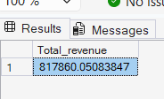
2.Average order value
SELECT SUM(total_price)/ COUNT(DISTINCT order_id) as avg_order_value from [sql management server name - Swap-N]
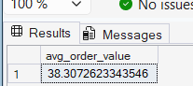
3.Total Pizza sold
SELECT SUM(quantity) as Total_pizza_sold from [sql management server name - Swap-N]
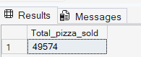
4.Total orders
SELECT COUNT(DISTINCT order_id) as Total_orders from [sql management server name - Swap-N]
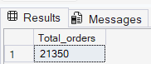
5.Average pizzas per order
SELECT CAST (CAST(SUM(quantity) as DECIMAL(10,2)) /
CAST(COUNT(DISTINCT order_id) as DECIMAL(10,2)) as DECIMAL(10,2)) as Avg_Pizzas_Per_order from [sql management server name - Swap-N]
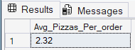
A. Daily Trend
SELECT DATENAME(DW , order_date) as order_day, COUNT(DISTINCT order_id) as Total_orders from [sql management server name - Swap-N]
GROUP BY DATENAME(DW , order_date)
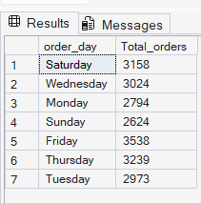
B. Hourly Trend
SELECT DATEPART(HOUR, order_time) as order_hours, COUNT(DISTINCT order_id) as Total_orders from [sql management server name - Swap-N]
GROUP BY DATEPART(HOUR, order_time)
ORDER BY DATEPART(HOUR, order_time)
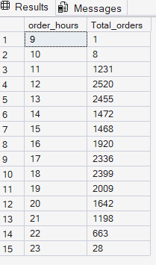
C. Percentage of sales by pizza category
SELECT pizza_category, SUM(total_price) as Total_Sales, SUM(total_price) * 100 / (SELECT SUM(total_price) from [sql management server name - Swap-N] WHERE MONTH(order_date) = 1) as PCT from [sql management server name - Swap-N]
WHERE MONTH(order_date) = 1
GROUP BY pizza_category
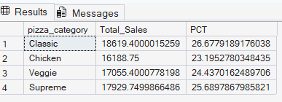
D. Percentage of sales by pizza size
SELECT pizza_size,CAST (SUM(total_price) as DECIMAL(10,2)) as Total_Sales, CAST (SUM(total_price) * 100 / (SELECT SUM(total_price) from [sql management server name - Swap-N] WHERE DATEPART(quarter,order_date)=1
) as DECIMAL(10,2)) as PCT from [sql management server name - Swap-N]
WHERE DATEPART(quarter,order_date)=1
GROUP BY pizza_size
order by PCT DESC
so in this we have seen the total pizza sales by pizza category for quarter of year
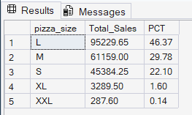
E. Total pizzas sold by pizza category
SELECT pizza_category, SUM(quantity) as Total_Pizzas_Sold from [sql management server name - Swap-N]
GROUP BY pizza_category
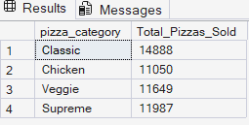
F. Top 5 best sellers by total pizzas sold
SELECT TOP 5 pizza_name, SUM(quantity) as Total_Pizzas_sold from [sql management server name - Swap-N]
GROUP BY pizza_name
order by Total_Pizzas_sold DESC
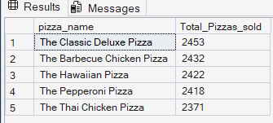
G. Bottom 5 worst sellers by total pizza sold
So in this we have seen worst sellers for 1 month
SELECT TOP 5 pizza_name, SUM(quantity) as Total_Pizzas_sold from [sql management server name - Swap-N]
WHERE MONTH(order_date)=1
GROUP BY pizza_name
order by Total_Pizzas_sold ASC
